Classes and Objects Exercise.
Create a class and program to instantiate the objects below and test them displaying results of the data that was loaded into each object.

Employee Class

Write a class named Employee that has the following member variables:

name—a string that holds the employee’s name

idNumber—a n int variable that holds the employee’s ID number

department—a string that holds the name of the department where the employee works

position—a string that holds the employee’s job title

he class should have the following constructors:

A constructor that accepts the following values as arguments and assigns them to the appropriate member variables: employee’s name, employee’s ID number, department, and position.

A constructor that accepts the following values as arguments and assigns them to the appropriate member variables: employee’s name and ID number. The department and position fields should be assigned an empty string ("").

A default constructor that assigns empty strings ("") to the name, department, and position member variables, and 0 to the idNumber member variable.

Write appropriate mutator functions that store values in these member variables and accessor functions that return the values in these member variables. Once you have written the class, write a separate program that creates three Employee objects to hold the following data:

Name ID Number Department Position
Susan Meyers 47899 Accounting Vice President
Mark Jones 39119 IT Programmer
Joy Rogers 81774 Manufacturing Engineer

Patient Charges

Write a class named Patient that has member variables for the following data:

First name, middle name, last name

Address, city, state, and ZIP code

Phone number

Name and phone number of emergency contact

The Patient class should have a constructor that accepts an argument for each member variable. The Patient class should also have accessor and mutator functions for each member variable.

Next, write a class named Procedure that represents a medical procedure that has been performed on a patient. The Procedure class should have member variables for the following data:

Name of the procedure

Date of the procedure

Name of the practitioner who performed the procedure

Charges for the procedure

The Procedure class should have a constructor that accepts an argument for each member variable. The Procedure class should also have accessor and mutator functions for each member variable.

Next, write a program that creates an instance of the Patient class, initialized with sample data. Then, create three instances of the Procedure class, initialized with the following data:

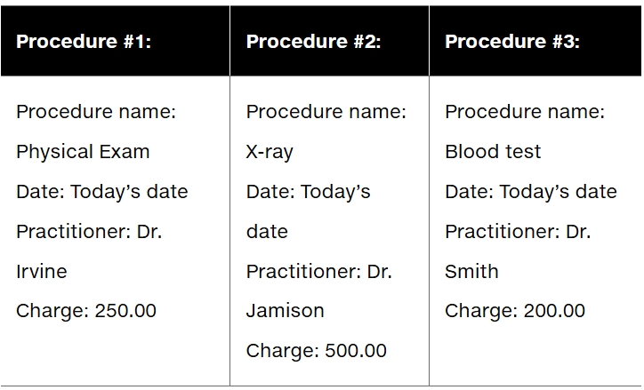

The program should display the patient’s information, information about all three of the procedures, and the total charges of the three procedures.

